Associated Data Files

<https://drive.google.com/file/d/0Bxr27gVaXO5sa0JBamZXdkpYUFk/view?usp=sharing>

1. Problem Statement

• Fetch date and temperature from temperature_data where zip code is greater than

300000 and less than 399999.

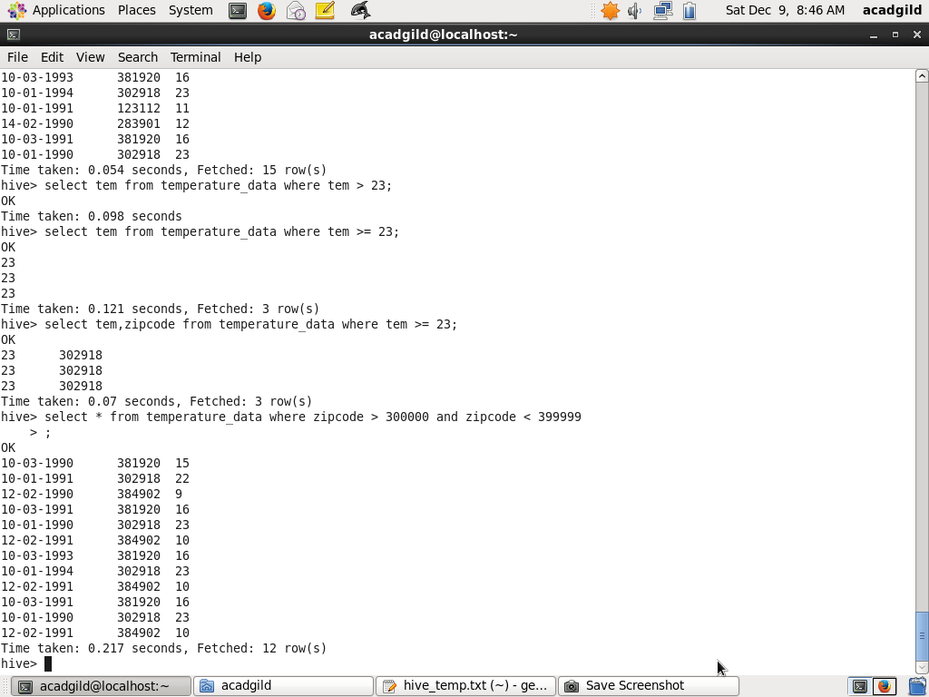

• Calculate maximum temperature corresponding to every year from temperature_data

table.

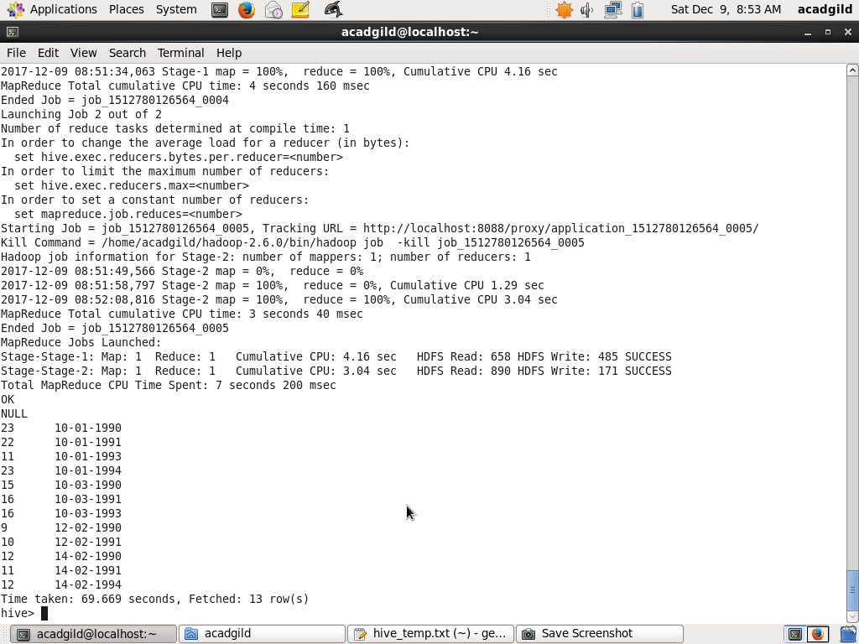

• Calculate maximum temperature from temperature_data table corresponding to those

years which have at least 2 entries in the table.

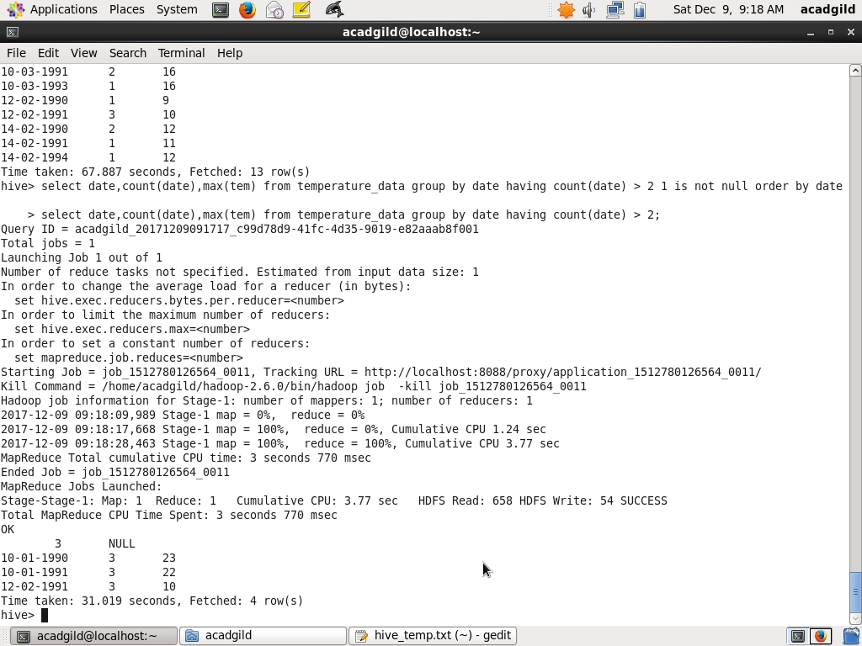

• Create a view on the top of last query, name it temperature_data_vw.

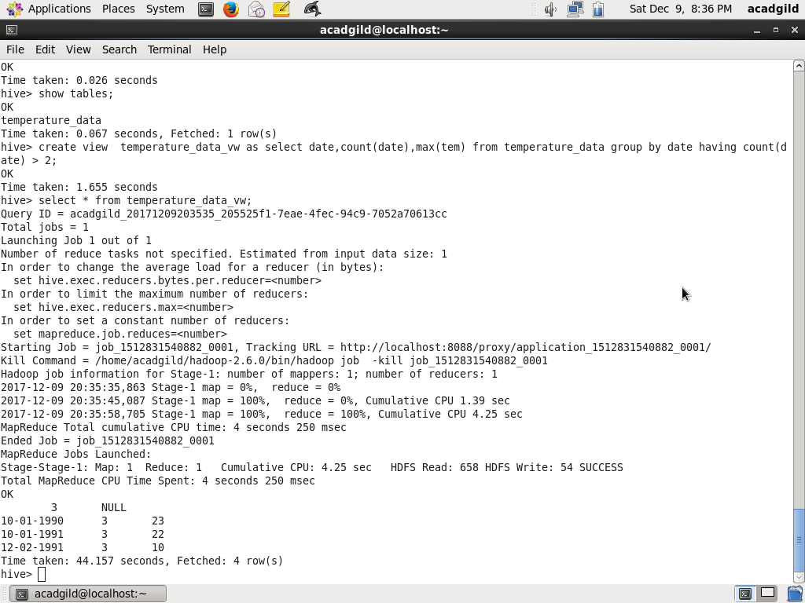

• Export contents from temperature_data_vw to a file in local file system, such that each

file is '|' delimited.

